VALENCE SHEET
CHEMISTRY I NAME________________________

CATIONS
+1 |  | +2 |  | +3 +4
Ag | Silver | Ba | Barium | Al | Aluminum | Pb | Lead (IV)
Au | Gold (I) | Be | Beryllium | As | Arsenic | Pt | Platinum (IV)
Cs | Cesium | Ca | Calcium | Au | Gold (III) | Sn | Tin (IV)
Cu | Copper (I) | Co | Cobalt (II) | B | Boron
Fr | Francium | Cr | Chromium (II) | Bi | Bismuth
H | Hydrogen | Cu | Copper (II) | Co | Cobalt (III)
Hg | Mercury (I) | Fe | Iron (II) | Cr | Chromium (III)
K | Potassium | Hg | Mercury (II) | Fe | Iron (III) |  | 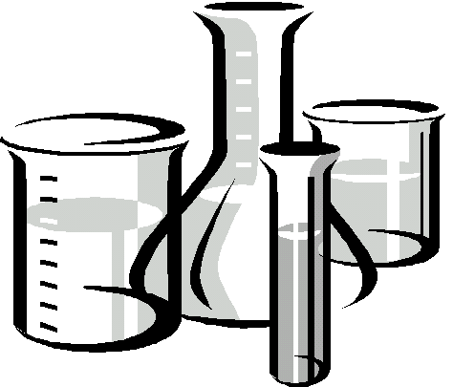
Li | Lithium | Mg | Magnesium | Ga | Gallium
Na | Sodium | Ni | Nickel (II) | In | Indium
NH₄ | Ammonium | Pb | Lead (II) | Ni | Nickel (III)
Rb | Rubidium | Pt | Platinum (II) | Sb | Antimony
 |  | Ra | Radium | Sc | Scandium
 |  | Sn | Tin (II) | Tl | Thallium
 |  | Sr | Strontium
 |  | Zn | Zinc
ANIONS
-1 |  | -2 |  | -3 |  | -4
At | Astitide | B₄O₇ | Tetraborate | AsO₄ | Arsenate | Fe(CN)₆ | Ferrocyanide
Br | Bromide | BO₃ | Borate | N | Nitride
BrO₃ | Bromate | C₂O₄ | Oxalate | P | Phosphide
C₂H₃O₂ | Acetate | C₄H₄O₆ | Tartrate | PO₃ | Phosphite
Cl | Chloride | CO₃ | Carbonate | PO₄ | Phosphate
ClO | Hypo-chlorite | Cr₂O₇ | Dichromate | SbO₄ | Antimonate
ClO₂ | Chlorite | CrO₄ | Chromate
ClO₃ | Chlorate | O | Oxide
ClO₄ | Perchlorate | O₂ | Peroxide |  |  |  | COVALENT
CN | Cyanide | S | Sulfide |  |  |  | PREFIXES
CNO | Cyanate | S₂O₃ | Thiosulfate |  |  |  | 1-mono
F | Fluoride | Se | Selenide |  |  |  | 2-di
HCO₃ | Hydrogen carbonate OR Bicarbonate | SiO₃  SnO₃  SO₃ | Silicate  Stannate  Sulfite |  |  |  | 3-tri  4-tetra  5-penta
I | Iodide | SO₄ | Sulfate |  |  |  | 6-hexa
IO₃ | Iodate | Te | Telluride |  |  |  | 7-hepta
MnO₄ | Permanganate |  |  |  |  |  | 8-octa
NO₂ | Nitrite |  |  |  |  |  | 9-nona
NO₃ | Nitrate |  |  |  |  |  | 10-deca
OH | Hydroxide

